**The meta-plot: A graphical tool for interpreting the results of a meta-analysis**

Marcel A.L.M. van Assen1,2

Olmo R. van den Akker1

Hilde E.M. Augusteijn1

Marjan Bakker1

Michèle. B. Nuijten1

Anton Olsson-Collentine1

Andrea H. Stoevenbelt1

Jelte M. Wicherts1

Robbie C.M. van Aert1

1 Department of Methodology and Statistics, Tilburg School of Social and Behavioral Sciences, Tilburg University, the Netherlands

2 Department of Sociology, Faculty of Social and Behavioural Sciences, Utrecht University, the Netherlands

**Keywords**

Meta-analysis, publication bias, statistical power, cumulative meta-analysis, funnel plot

**Abstract**

The meta-plot is a descriptive visual tool for meta-analysis that provides information on the primary studies in the meta-analysis and the results of the meta-analysis. More precisely, the meta-plot portrays (i) the precision and statistical power of the primary studies in the meta-analysis, (ii) the estimate and confidence interval of a random-effects meta-analysis, (iii) the results of a cumulative random-effects meta-analysis yielding a robustness check of the meta-analytic effect size with respect to primary studies’ precision, and (iv) evidence of publication bias. After explaining the underlying logic and theory, the meta-plot is applied to two cherry-picked meta-analyses that appear to be biased and to ten meta-analyses randomly selected from the psychological literature. We recommend using the meta-plot in addition to any meta-analysis of common effect size measures, rather than variants of the funnel plot.

Meta-analysis has become one of the most important tools for researchers to gain an overview of the existing literature within a specific area, particularly as the numbers of journals and articles have grown exponentially over the years. Meta-analyses statistically combine the results from similar studies and yield estimates of average effect size, between-study variance in true effect size (i.e., heterogeneity in true effect size), and moderators of the effect size (Borenstein et al., 2009).

The quality of the output of a meta-analysis is largely determined by the accuracy and precision of its estimates. The accuracy of a meta-analysis is the difference between the estimated average effect size and the true effect size. The bigger this difference, the less accurate and the more biased the average effect size estimate will be. The precision of the average effect size estimate is inversely related to its uncertainty or standard error.

There are many factors that influence the accuracy (bias) and precision of the meta-analytic average effect size estimate. For example, the number of primary studies generally positively affects the precision of the meta-analytic effect size estimate, while each primary study’s number of observations also positively affects the estimate’s precision. Another important factor that affects the accuracy and precision of a meta-analysis is publication bias: the selective publication of studies with a favorable, usually statistically significant, outcome. In case of publication bias, meta-analytic average effect sizes will be overestimated (i.e., the accuracy of the effect size estimator decreases). This problem is aggravated for smaller study sample sizes (Nuijten et al., 2015). Importantly, the bias of the average effect size estimate is not ameliorated by including a large number of studies in a meta-analysis; the accuracy of the average effect size estimate of one large study is higher than of a meta-analysis based on say 1,000 smaller primary studies (Nuijten et al., 2015) Study-level *p*-hacking, questionable research practices aimed at achieving statistically significant *p*-values (John et al., 2012), may also adversely affect the average effect size estimates of meta-analyses, but its effects can be unpredictable (Van Aert et al., 2016). The interpretation of the output of meta-analyses becomes even more difficult because fields may differ in publication bias and *p*-hacking, as fields also differ in their distribution of effect sizes and sample sizes (Open Science Collaboration, 2015).

Because publication bias can seriously affect a meta-analysis’ accuracy, it is important to check whether there is evidence for publication bias in a meta-analysis. However, current methods to detect publication bias in meta-analysis often lack statistical power (Begg & Mazumdar, 1993; Sterne et al, 2000). Furthermore, existing methods to correct for publication bias often depend on strong assumptions, and effect size estimates between these correction methods can vary substantially for the same meta-analysis (Carter et al., 2019; McShane et al., 2016; Van Aert et al, 2019). The new method we present here enables the examination of whether extreme publication in combination with a true zero effect size can alternatively explain the meta-analytic effect size, but avoids these problems.

In this paper, we present the meta-plot, a general and descriptive graphical tool for meta-analysis. Meta-plot provides information on most of the aforementioned aspects of a meta-analysis. Specifically, the meta-plot portrays (i) the precision and statistical power of the primary studies in the meta-analysis, (ii) the average effect size estimate and confidence interval of random-effects meta-analysis, (iii) the results of a cumulative random-effects meta-analysis yielding a robustness check of the meta-analytic average effect size with respect to primary studies’ precision, and (v) evidence of publication bias. Because of providing these useful pieces of information we recommend using the meta-plot in addition to any meta-analysis.

In the next section, we will first compare the meta-plot to existing methods to detect and correct for publication bias. Next, we will outline two cherry-picked examples of meta-analyses, including their funnel plots as well as the results of some publication bias methods. In the subsequent section, we use these two examples to explain the meta-plot and its characteristics. Thereafter, we apply and interpret the meta-plot to ten meta-analyses randomly selected from the psychological literature to illustrate how the meta-plot aids the interpretation of a meta-analysis. Finally, we also illustrate a user-friendly web-application of the meta-plot. All the code to run the plots in this paper can be found at <https://osf.io/eayfr/>.

**Meta-plot compared to existing publication bias detection and correction methods**

What is the added value of a meta-plot, when so many meta-analytic tools are already available? As traditional meta-analytic effect size estimates can be highly misleading in the presence of publication bias, many tools have been developed to detect and correct for this bias. Unfortunately, tools attempting to detect publication bias or more generally small-study effects are hampered by a lack of statistical power. A small-study effect is present when smaller studies go along with larger effect size estimates. Small study effects are often interpreted as a sign of publication bias, although it has a number of possible causes (Sterne et al., 2011). The reasons are that smaller studies require larger effect sizes to become statistically significant, and that mainly (only) these significant effect sizes get selected for the meta-analysis in the presence of publication bias. However, as it may have other causes (e.g., researchers may design small (large) studies when they expect a larger (smaller) true effect size, or outcome reporting bias, etc.), we caution against routinely interpreting a small-study effect as a sign of publication bias.

Popular tests for small-study effects such as Egger’s test (Egger et al., 1997) or the Begg-Mazumdar’s correlation test (Begg & Mazumdat, 1993) generally only have sufficient statistical power to detect small-study effects when the effect is substantial and at the same time the number of studies in the meta-analysis is large (Begg & Mazumdar, 1993; Sterne et al., 2000). The meta-plot is a visual tool that does not statistically test for small-study effects or publication bias.

Because of the relatively low power associated with the detection of small-study effects, methods that correct for small-study effects or publication bias may seem preferable to tools detecting these effect or bias. Unfortunately, effect size estimates between these correction methods can vary substantially for the same meta-analysis, as they are often based on different (strong) assumptions. Moreover, their performance is known to be questionable under some conditions. For instance, none of the adjustment methods trim-and-fill (Duval & Tweedie, 2000a; 2000b), selection models (Hedges & Vevea, 2005), PET-PEESE (Stanley & Doucouliagos, 2014), *p*-curve (Simonsohn et al., 2014), or *p*-uniform (Van Aert et al., 2016; Van Assen et al., 2015) consistently work well when the true effect size is heterogeneous (Borenstein et al., 2009). As heterogeneity of effect size is usually unknown a priori, and publication bias may itself affect the assessment of heterogeneity (Augusteijn et al., 2019) no practical guidelines yet exist for researchers on how and when to interpret effect size estimates of these methods.

Another, and popular, alternative for examining small-study effects and publication bias is the funnel plot (Light & Pillemer, 1984). The funnel plot is a scatter plot of primary studies’ effect estimates (usually on the *x*-axis) against some measure of each study’s size or precision (*y*-axis). In case of a small-study effect, a funnel plot tends to be asymmetric with relatively few studies in the lower-left corner of the plot in case of a positive meta-analytic effect size and in the lower-right corner of the plot in case of a negative meta-analytic effect size. The contour-enhanced funnel plot adds contours to the plot depending on the statistical significance or *p*-value of the primary study effect size, which may help distinguishing publication bias from other sources of funnel plot asymmetry (Peters et al., 2008). See Figure 1 for examples.

Although popular and widely applied, the funnel plot has been criticized because it is misleading (Lau et al., 2006; Tang & Liu, 2000) and overly subjective, as arbitrarily changing the definition of precision and/or effect size altered the conclusion about the shape of the plot in 86% of the funnel plots in Tang and Liu (2000). The meta-plot is a superior alternative to the funnel plot that mostly alleviates the disadvantages of the funnel plot while presenting essential information about the primary studies, the field in which the meta-analysis was conducted (i.e., the discipline in which the meta-analysis was carried out, e.g. visual perception, social cognition, etc.), and the results of sensitivity analyses that all aid the interpretation of the meta-analytic result.

**Illustrating the meta-plot with two cherry-picked example meta-analyses**

To illustrate the meta-plot, we cherry-picked two meta-analyses that show signs of publication bias and overestimated effects. Later in the paper, we will also show the meta-plot on ten randomly selected meta-analyses.

The first example meta-analysis of McCall and Carriger (1993) focuses on infant habituation and memory performance as predictors of later IQ, as assessed with the Pearson correlation coefficient. Twelve studies are included in this meta-analysis, with each study contributing one effect size to the analysis. Eleven of the effect sizes were statistically significant based on a two-tailed test with α = .05, and sample sizes of the primary studies varied from 11 to 96 (mean = 37.25, sd = 29.05). A random-effects meta-analysis was conducted on the Fisher-*z* transformed correlations, using the Paule-Mandel estimator (Paule & Mandel, 1982) for the between-study variance in true effect size. The meta-analysis yielded a correlation estimate equal to *r* = .390, *p <* .001, 95% CI [.306; .469]. No evidence of heterogeneity was obtained (${\hat{τ}}^{2}$ = 0, *Q*(11) = 6.74, *p* = .820; *I*2 = 0, 95% CI [0; 38.76]).

The left column of Figure 1 shows the funnel plot (top) and contour-enhanced funnel plot (bottom) of the meta-analysis. These plots suggest a small-study effect as primary study effect size seems to be negatively associated to sample size (Egger’s test *z* = 2.241, *p* = .025). *P*-uniform (Van Aert et al., 2016; Van Assen et al., 2015), a method to test and correct for publication bias, indicates that publication bias (at least partly) causes the small-study effect (L = 2.615, *p* = .005) in the meta-analysis of McCall and Carriger.

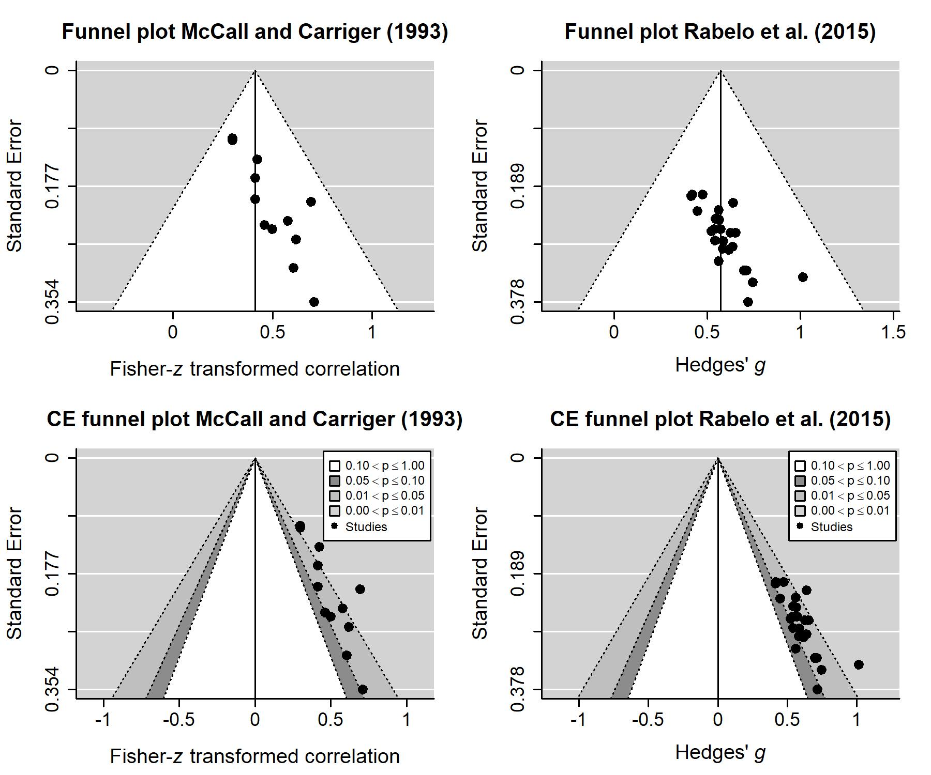

Figure 1. Funnel plots (first row) and contour-enhanced funnel plots (second row) of McCall and Carriger (1993; first column) and Rabelo et al. (2015; second column).

Adjusting for publication bias, *p*-uniform’s estimate equaled *r* = .177 (*p* = .119, 95% CI [-.233; .340]), whereas the estimate of the selection model approach by Vevea and Hedges (1995) to correct for publication bias was *r* = .263 (*p* < .001, 95% CI [.224; .301], ${\hat{τ}}^{2}$ = 0). To conclude, both the funnel plots, publication bias tests, and publication bias correction methods suggest that the meta-analysis overestimates the true effect size because of publication bias; the evidence in favor of an association between infant inhabitation and later IQ is substantially smaller than suggested by the random-effects meta-analysis.

The second example meta-analysis of Rabelo et al. (2015) studies the relation between the sensation of weight and moral judgement of importance. This meta-analysis contains 25 effect sizes, transformed to standardized mean difference Hedges’ *g*, with 23 being statistically significant if tested two-sided with α = .05, and all of them being statistically significant if tested one-sided. The average sample size is 61.12 (sd = 20.22, *N* ranging from 30 to 100). The random-effects meta-analysis resulted in a statistically significant medium effect size estimate of *g* = 0.571, *p* < .001, 95% CI [0.468: 0.673], and ${\hat{τ}}^{2}$ = 0 (*Q*(24) = 4.6, *p* = .999993; I2 = 0, 95% CI [0, 0]), signaling extreme homogeneity, which is a sign of publication bias (Augusteijn et al., 2019). Data and code of Rabelo et al. can be found at <https://osf.io/cgmdi/>.

The funnel plot and contour-enhanced funnel plots are shown in the right column of Figure 1. It suggests small-study effects, although Egger’s test was not statistically significant (*z* = 1.629, *p* = .103). *P*-uniform signaled publication bias (L = 4.8, *p* < .001), and yields a statistically non-significant estimate of the effect size of *g* = -0.149, *p* = .789, 95% CI [-0.628; 0.186]. The estimate of the effect size by the selection model approach was 0.254 (*p* < .001, 95% CI [0.220; 0.289]with ${\hat{τ}}^{2}$ = 0. To conclude, although random-effects meta-analysis suggested a medium effect size, further analyses provided strong indications of publication bias and weaker evidence of a nonzero association between the sensation of weight and moral judgement of importance. Figure 2 shows the *meta-plot* (first row) and *summary meta-plot* (second row) for both examples. These meta-plots, and their advantages compared to the funnel plots, are explained in the next section.

Figure 2. Meta-plots (first row) and summary meta-plots (second row) of McCall and Carriger (1993; first column) and Rabelo et al. (2015; second column).

*The meta-plot*

The meta-plot contains four different pieces of information: the (i) precision and statistical power of research summarized in the meta-analysis, (ii) the estimate and confidence interval of a random-effects meta-analysis, (iii) the robustness of the effect size estimate with respect to primary studies’ precision (cumulative meta-analysis), and (iv) evidence of publication bias. We discuss each of these in turn, by first discussing the underlying theory, followed by an explanation of each element in the meta-plot and its application to the two examples introduced in the previous section. For illustration and better understanding, Figure 3 shows again the summary meta-plot of McCall and Carriger (1993) with a brief explanation of four aforementioned elements.

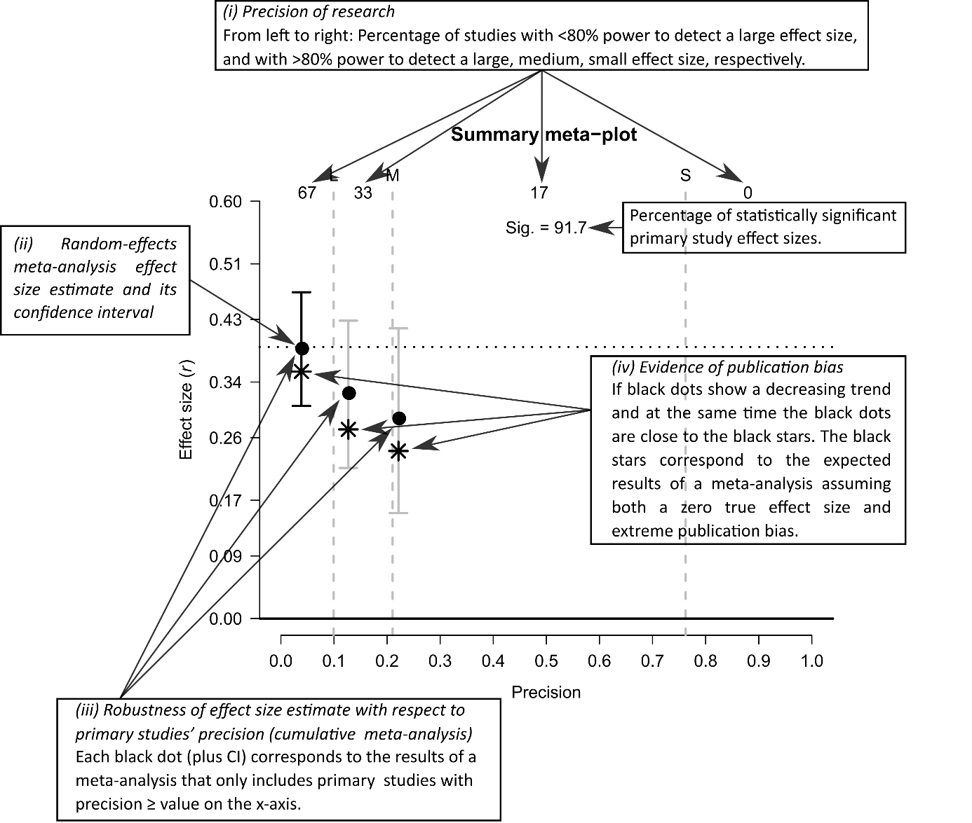Figure 3. Overview of a summary meta-plot with a brief explanation of its elements.

*(i) Precision of research*

The precision of an effect size estimate is here defined as the reciprocal of its standard error[1], and is directly and positively related to the sample size on which the estimate is based. If (and only if) the true effect size differs from zero, precision is also directly and positively related to the statistical power of the study.[2] Large sample size and sufficient statistical power are generally considered as signs of high quality in an empirical study (Aberson, 2011; Ellis, 2010). Illustrating the importance ascribed to the statistical power of a study, the American Psychological Association (APA) has recommended doing a power analysis preceding empirical studies (Wilkinson, 1999). In a similar vein, we believe it is important that a descriptive meta-analytic tool provides summary information on the precision of individual studies and their statistical power. The meta-plot does just that by showing the top the percentage of primary studies having at least 80% statistical power to detect a small (S; Cohen’s *d*: *d* = 0.2, Pearson correlation coefficient: *ρ* = 0.1), medium (M; *d* = 0.5, *ρ* = 0.3), and large (L; *d* = 0.8, *ρ* = 0.5) effect. Although these effect sizes and their labels, formulated by Cohen (1988) are rather arbitrary, they are well-known and often used. In case another true effect size value is meaningful to the researcher, or a certain precision or sample size, the researcher is recommended to focus on the estimated effect size based on the primary studies having at least that precision rather than on those (‘small’, ‘medium’, ‘large’ effect size) in the meta-plot.

Next to being less precise, small studies are generally also associated with larger overestimation of effect sizes in the presence of publication bias (Bakker et al, 2012; Nuijten et al., 2015), and hence relatively many false positives get published where the true effect size is zero (Van Assen et al., 2015) Consequently, in a research field where small studies are ubiquitous and publication bias is present, a zero true effect size may still yield a statistically significant, medium or even large effect size estimate in a meta-analysis.

Although we believe that the precision of the research summarized by the meta-analysis is informative as such, we argue against dismissing the results of a meta-analysis based on small studies per se. First, if the true effect size is (very) large in a field, small studies can have sufficient statistical power and result in little overestimation, even in the presence of publication bias (Nuijten et al., 2016). Second, even when the true effect size is zero or small, small studies are not at all problematic in a field with no publication bias and no questionable research practices, as these studies do not yield biased estimates of the effect (but only less precise estimates). One could even argue that in such an unbiased field, multiple small studies are preferable to a few large studies (keeping constant sample size across studies), as the multiple small studies provide more evidence on heterogeneity and moderator effects.

Currently, however, publication bias and questionable research practices seem to affect many fields of research (Fanelli, 2010; Fanelli et al., 2017; Ferguson & Brannick, 2012; Levine et al., 2009).Moreover, in many research areas, researchers cannot be certain they are examining a (very) large true effect size. As a consequence, interpreting the results of a meta-analysis incorporating many small studies, particularly if they have *p*-values just below .05, is tricky. These *p*-values just below .05 may be a signal of a true nonzero effect, or just the result of a combination of a true zero effect and publication bias, questionable research practices, and “luck”. The fourth element of the meta-plot, which will be explained later, will help distinguish between results arising from non-zero true effects and those arising from zero true effects in a field with publication bias.

Turning to the meta-plot, the top of the plot shows the precision of the primary studies in the meta-analysis, using four percentages. The first percentage to the left gives the percentage of primary studies in the meta-analysis that do *not have* sufficient statistical power to detect a large population effect. “Sufficient statistical power” is operationalized as 80% power as proposed by Cohen (1988), using a two-tailed test with *α* = .05 and assuming a between-subjects design. The arrow pointing to the left indicates that so many studies *fail* to have sufficient power.

The other three percentages and arrows pointing to the right refer to the percentage of primary studies *succeeding* to have sufficient power to detect a large (L), medium (M), and small effect (S), respectively. Note that the first two out of four percentages always add up to 100%. The vertical lines in the plot correspond to the sample sizes needed for sufficient power, for either studies on correlations (29, 84, 782) or studies comparing the means of two independent populations using a balanced design with equal group sizes (52, 128, 784). More detailed information on studies’ precision can be obtained from primary studies’ position on the *x*-axis, which is directly related to the study’s sample size (see Appendix A1 for calculating a study’s precision and position on the *x*-axis).

It is important to note that the *x*-axis of the meta-plot is the same across applications, meaning that it is not affected by the precision of the primary studies summarized in the meta-analysis. This facilitates comparing different meta-analyses and their meta-plots. The use of a standard format in the meta-plot also helps eliminate the subjectivity that is characteristic of the funnel plot (Tang & Liu, 2000). The maximum precision value of 1 on the *x*-axis in the meta-plot always translates to a sample size that equals 1,300. This is close to the sample size needed to have a statistical power of 95% to detect a small true effect size; for correlations and comparing two population means 1,293 and 1,302 observations are needed, respectively. The *x*-axis is approximately linear in precision, meaning that it is on a square root scale of sample size. Consequently, the *x*-axis approximates a ratio scale of primary studies’ precision.[3]

Turning to the meta-plots of the two examples shown in the first row of Figure 2, it is clear that the primary studies’ precision in both meta-analyses is low. These meta-analyses contained many small studies with insufficient statistical power to detect a true large effect size (40% of the studies in Rabelo et al., 2015, and 67% of the studies in McCall and Carriger, 1993), and many studies with sufficient statistical power to detect a large but not a medium true effect size (60% in Rabelo et al. and 33% in McCall and Carriger). Whereas the meta-analyses did not contain any large studies with sufficient statistical power to detect a small true effect size, McCall and Carriger contained two studies (17%) with (barely) sufficient statistical power to detect a medium true effect size. Finally, note that the funnel plot (first row of Figure 1) does not contain any information on statistical power of individual studies to detect a certain true effect size.

*(ii) Random-effects meta-analysis effect size estimate and its confidence interval*

In line with the usual desire of researchers to generalize the results of a meta-analysis to studies that were not included (Aguinis et al., 2010; Hunter & Schmidt, 2000), we chose to calculate and depict the random-effects meta-analysis effect size estimate and its 95% confidence interval (CI95) in the meta-plot by default. The random-effects model implies that the researcher assumes that the true effect sizes incorporated in the meta-analysis are a (random) sample of a larger normally distributed population of effect sizes, and wishes to generalize his/her inferences to that population. It enables estimating the between-study variance in true effect size. Many methods for estimating this between-study variance exist. We implemented the Paule-Mandel estimator as it generally shows the best statistical properties (Langan et al., 2016; Veroniki et al., 2016)and has attractive theoretical properties (Van Aert & Jackson, 2018). For our estimation we used the R package metaphor (Viechtbauer, 2010). Although the random-effects model is often recommended as the default choice, it must be noted that the fixed-effect model is to be preferred if inference is limited to the studies in the meta-analyses, even if effect size seems heterogeneous (Hedges & Vevea, 1998; Rice et al., 2018). The user of meta-plot can also choose to depict the results of fixed meta-analysis.

In the meta-plot, the random-effects meta-analysis effect size estimate is represented by the dotted horizontal line. For convenience and easy of interpretation, each effect size’s direction is reversed in case the meta-analysis effect size estimate is negative.

The estimate and its CI95 are also shown by the leftmost vertical line in the plot, where the estimate is represented by the black dot that naturally lies on the horizontal dotted line. As the meta-plot always shows the value 0 on the *y-*axis representing the effect size, the hypothesis of a zero true effect size is tested (two-tailed) by checking if the CI95 contains the value 0.

The meta-plots for the two examples in the first row of Figure 2 show that both effect size estimates (approximately *r* = .39 for McCall and Carriger, 1993, and *g* = 0.571 for Rabelo et al., 2015) are above zero, and highly statistically significant (i.e., very small *p*-values) as the value 0 lies outside their confidence intervals. Note that the funnel plots in Figure 1 also show the effect size estimate of a random-effects meta-analysis, but generally does not show its precision or 95% confidence interval.

*(iii) Robustness of effect size estimate with respect to primary studies’ precision (cumulative meta-analysis)*

The third element depicted by the meta-plot is the result of all meta-analyses based on studies with a certain precision or larger. That is, each black dot at a certain *x*-value represents the effect size estimate of a random-effects meta-analysis based on all primary studies with precision *x* *or larger*.[4] Thus, a black dot represents the results of a meta-analysis, and not of a single primary study. The CI95 of each estimate is also presented by a vertical line. The results of the meta-analysis of very precise studies (*x* > 1) are presented at the complete right of the plot (*x* = 1).

The collection of black dots are the results of a *cumulative meta-analysis with respect to precision*. Others have already suggested using a cumulative meta-analysis for assessing whether a negative relationship exists between precision and observed effect size; a small-study effect (Atakpo & Vasar, 2016; Borenstein et al., 2009; Leimu & Koricheva, 2004). We implemented this suggestion in the meta-plot.

The meta-plot makes small-study effects visible: if it is the case that large effect sizes are associated with smaller studies, the black dots in the meta-plot would generally decrease from left to right. Small-study effects may also be visible from a funnel plot by funnel plot asymmetry, but it is often difficult to visually identify this asymmetry in a funnel plot (Terrin & Schmid, 2005). Small-study effects are easier to identify in the meta-plot as the estimates are more precise (less variable) than those in the funnel plot, and are also related to each other as opposed to those in the funnel plot. More specifically, dots in the funnel plot are based on effect sizes of primary studies, whereas the dots in the meta-plot are based on the results of a cumulative meta-analysis. That is, the leftmost black dot is a meta-analysis based on all studies, the black dot to the right of the leftmost one is the meta-analysis based on all studies except for the one with the lowest precision, etc. As estimates are not only more precise, but also use overlapping information, a possible trend is generally clearer from a meta-plot than from a funnel plot.

We, however, should add a cautionary note when using the meta-plot to conclude evidence of a small-study effect. For instance, consider a meta-analysis consisting of ten primary study effect sizes differing in precision, with equal effect size estimates for the nine least precise studies and a lower effect size estimate of the most precise study. In that case, the cumulative meta-analysis will show a downward trend suggesting strong evidence of a small-study effect. Although a small-study effect arguably exists in this particular example, evidence in favor of it is weak at best since the lower effect size estimate of the most precise study may also be the result of sampling error. We therefore recommend caution concluding a small-study effect based on the meta-plot alone.

Turning to the meta-plots in the first row of Figure 2, we clearly see a decreasing trend in the black dots pointing out small-study effects in both meta-analyses. The funnel plots and contour-enhanced funnel plots also clearly show an association between primary study’s precision and their effect size, although variability of estimates is much higher than in the meta-plot. Partly, the association is so clearly visible in these funnel plots because we (cherry-)picked the meta-analyses for their strong evidence of small-study effects.

The results of the cumulative meta-analysis in the meta-plot also provide other useful perspectives for interpretation which are not provided by the funnel plot. As overestimation of average effect size in a meta-analysis is most prevalent if the included primary studies have small sample sizes, researchers have suggested to exclude such small and possibly biased studies from a meta-analysis (Button et al., 2013; Ioannidis, 2008; Kraemer et al., 1998; Nuijten et al., 2015). Stanley et al. (2010) proposed to discard the 90% least precise observed effect sizes in a meta-analysis and interpret the mean of only the 10% most precise effect sizes as meta-analytic effect size estimate. As methods such as this proposed estimator can be less biased in case of publication bias, they are recommendable as sensitivity analyses when conducting a meta-analysis.

Turning to the meta-plots of the example meta-analyses (first row of Figure 2), we see that for both examples the meta-analytic estimates based on approximately the 10% most precise studies as well as the estimate of only the largest study (rightmost dot with CI95) are statistically significantly different from zero. However, as is clear from the *x*-axis of the meta-plots, neither meta-analysis includes a large study (i.e., the study with the largest sample size is 96 for McCall and Carriger, 1993, and 100 for Rabelo et al., 2015), which implies that even the estimate of the largest study may have considerable bias in case of publication bias combined with a zero true effect size. This dependence on the precision of the largest included studies, where the largest studies may still be small and result in overestimation of effect size, can therefore be considered a limitation of relying on meta-analysis based on only the 10% most precise studies.[5]

As such, we advise to also consider the estimates of meta-analyses based on primary studies with sufficient statistical power given a small, medium, and large true effect size. These are shown in the *summary meta-plots* in the second row of Figure 2. Next to the estimate and CI95 of the meta-analyses including all studies (leftmost), it shows these results for studies with sufficient power (80%) to detect a large true effect size (left vertical line), medium true effect size (middle), and small true effect size (right). Note that the summary meta-plot is just the meta-plot with (often many) dots left out, keeping only the leftmost dot and those immediately to the right of the vertical lines. As such the summary meta-plot is more transparent than the meta-plot if the meta-analysis is conducted on many studies. Additionally, small-study effects will also be visible from the summary meta-plot. We therefore recommend reporting the summary meta-plot in meta-analyses including many studies.

The summary meta-plots of the examples indeed also suggest small-study effects. The plot of McCall and Carriger (1993) only shows the results of three meta-analyses, as no studies were conducted with sufficient statistical power to detect a small effect. Similarly, the summary meta-plot of Rabelo et al. (2015) only shows the results of two cumulative meta-analyses, as it does not contain studies with sufficient statistical power to detect a medium effect.

*(iv) Evidence of publication bias*

The last and fourth optional element enables examining potential publication bias. That is, whether a statistically significant meta-analytic effect size can be explained by publication bias. Particularly, it is assumed that statistically non-significant effect sizes are suppressed relative to statistically significant effect sizes, based on a one-tailed test. This implies that this element of the meta-plot will not assist in detecting publication bias where significant effect sizes are suppressed or where both significant negative and positive effects are published with higher probability.

The meta-plot presents the expected results of the cumulative meta-analysis based on a zero true effect in combination with extreme publication bias (i.e. if only statistically significant results get included in the meta-analysis) using black stars. Concisely, if the black dots (results of cumulative meta-analysis) are above the black stars, a zero true effect size in combination with extreme publication bias cannot explain the results and it can be safely concluded that true effect size exceeds zero. However, if the black dots are not above the black stars, an alternative explanation of the effect in the meta-analysis is extreme publication bias in combination with a zero true effect size and we recommend not to interpret the statistically significant meta-analytic effect size estimate as evidence of a nonzero true effect size.[6]

See Appendix A2 for the technical details on how the results corresponding to the black stars are calculated. This method of detecting publication bias only makes sense if most primary studies are statistically significant; after all, if a meta-analysis includes a substantial proportion of non-significant studies, this is already evidence in itself that publication bias is not extreme. Therefore, this element of the meta-plot is only shown if at least 80% of the primary effect sizes are statistically significant.[7]

The expected effect sizes based on a zero true effect size combined with extreme publication bias necessarily decrease with studies’ increasing precision, as overestimation by publication bias decreases with increased precision. As such, the expected effect sizes also depict small-study effects. The value of the expected results in assessing publication bias lies in its comparison with the results of the cumulative meta-analysis based on the precision of the primary studies (the black dots). In case of a nonzero true effect size, the black dots are expected to lie above the black stars. If the black dots are not above the black stars, an alternative explanation of the effect in the meta-analysis is publication bias.

We could apply our method to assess publication bias on both the meta-plots of McCall and Carriger (1993) and Rabelo et al. (2015), because they both contain more than 80% statistically significant primary effect sizes (12 of 13 versus 23 of 25). As the black dots of McCall and Carriger lie above the black stars that are expected from extreme publication bias, publication bias cannot entirely explain the observed effects suggesting a nonzero true effect size may exist. In the meta-plot of Rabelo et al. on the other hand, the black dots almost coincide with the black stars , showing that the results of the meta-analysis can be entirely explained by a zero true effect size in combination with extreme publication bias. Note that these results for both meta-analyses are also in line with the majority of the results of the publication bias methods reported earlier. Finally, while the funnel plot only provides evidence of small-study effects and not publication bias, the contour-enhanced funnel plots in Figure 1 helps to distinguish publication bias as a cause of small-study effects. Both contour-enhanced funnel plots indeed provide evidence of publication bias, as most primary study effect sizes appear ‘just statistically significant’. However, as opposed to the meta-plot, the contour-enhanced funnel plot cannot tell if the meta-analytic results can or cannot be alternatively explained by a zero true effect size in combination with extreme publication bias.

**Meta-plot of random sample of meta-analyses**

To show the possibilities of our newly developed tool and show how it can be interpreted, we applied the meta-plot to a representative sample of meta-analyses that is examined in Bakker et al. (2012). To collect this sample, 108 peer-reviewed articles published in 2011 that contained the strings “research synthesis”, “systematic review”, or “meta-anal*” in the title and/or abstract were retrieved from the PsycARTICLES database. After a random number between 1 and 108 was assigned to all articles, Bakker et al. started checking the articles with the lowest numbers and continued until they included eleven articles. Only meta-analyses that reported the effect sizes and standard errors (or sample sizes) of primary studies were included. From each meta-analysis they retrieved the subset (as selected by the authors of the meta-analyses) of at least ten primary studies that was the most homogeneous subset in terms of the *I2*-statistic. The included meta-analyses were from clinical, counseling, education, evolutionary, developmental, family, and industrial/organizational psychology. See Bakker et al. for details on the meta-analysis selection, and their appendix for details on the included meta-analyses.

We created meta-plots for ten of the eleven included meta-analyses in Bakker et al. (2012).The meta-analysis by Hallion and Ruscio (2011) was excluded, because a dependent samples design was used in this meta-analysis and we could not derive the exact precision of primary study effect sizes in that meta-analysis as the correlation between the two measurements was unknown. We show both the meta-plots (Figure 4) and summary meta-plots (Figure 5), but our interpretation mainly focuses on the meta-plots in Figure 4.

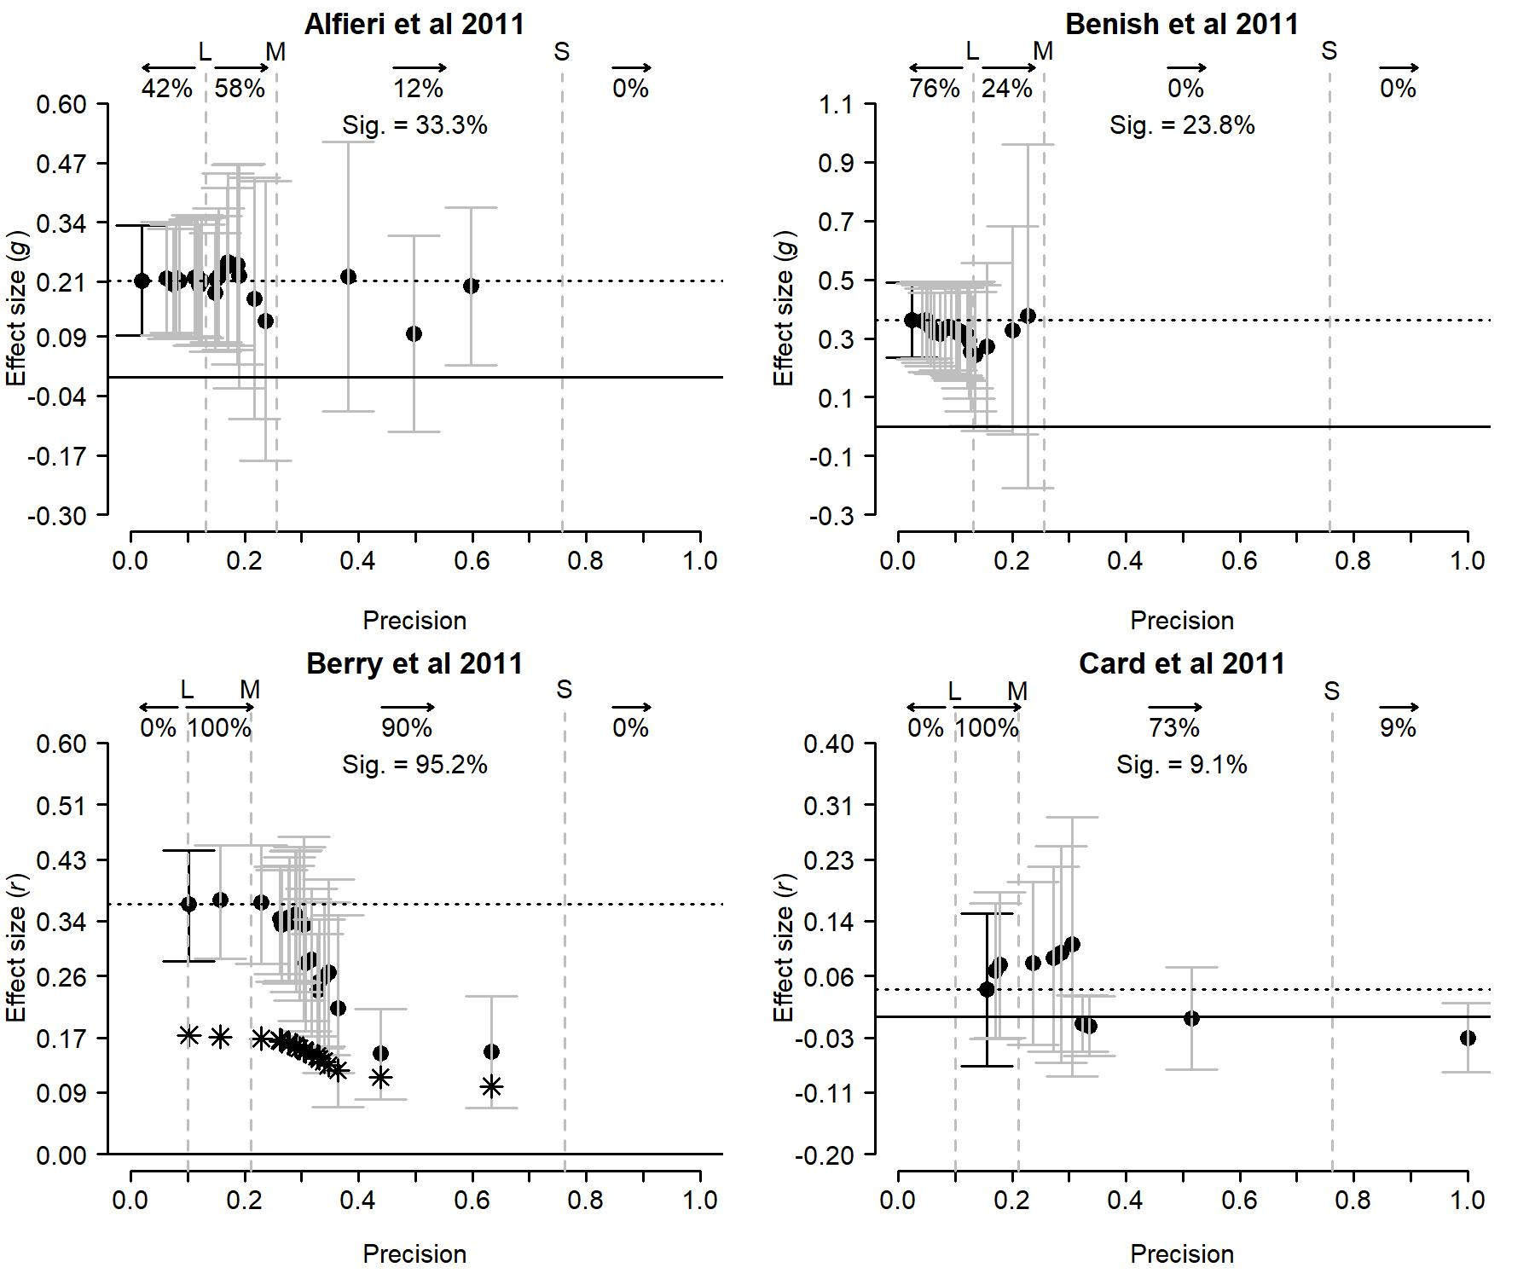

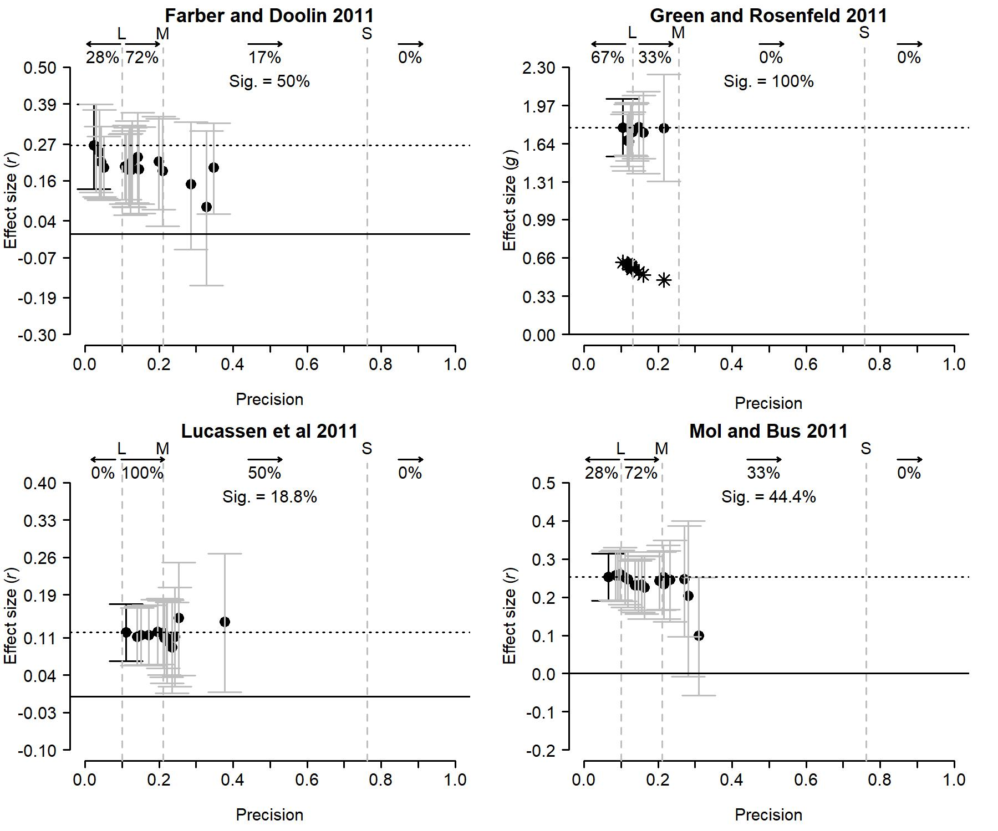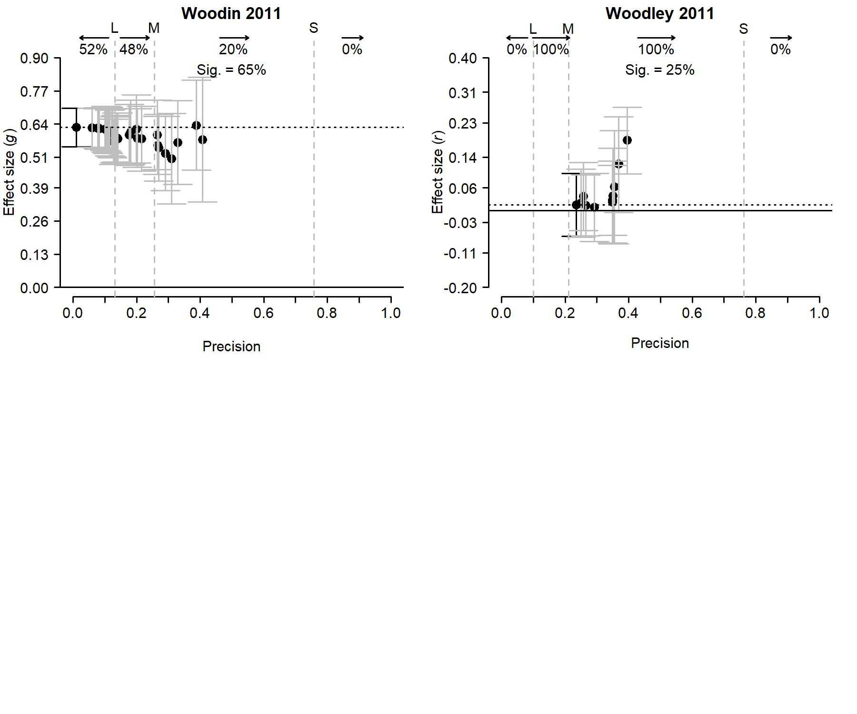

Figure 4. Meta-plots of the ten randomly selected meta-analyses.

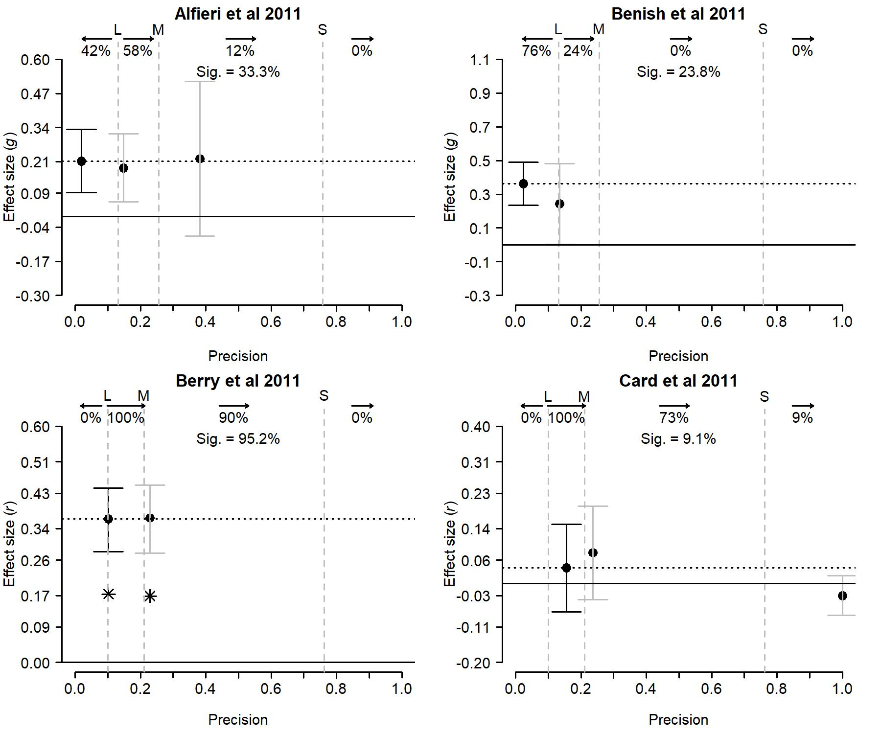

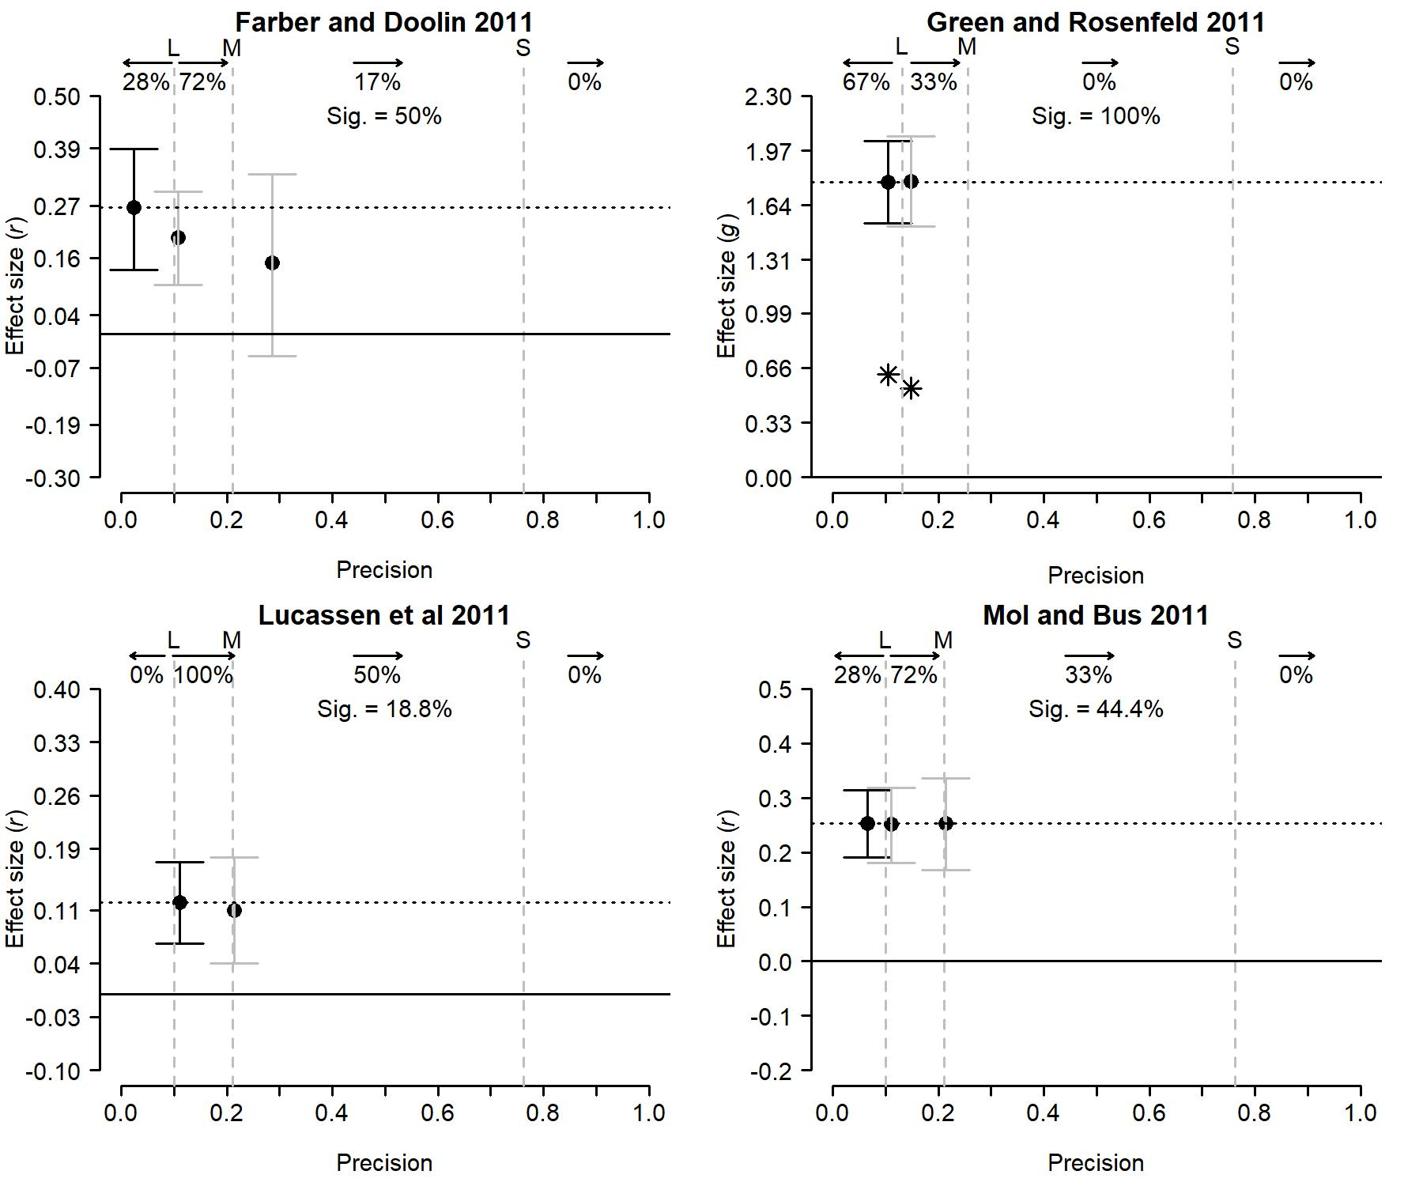

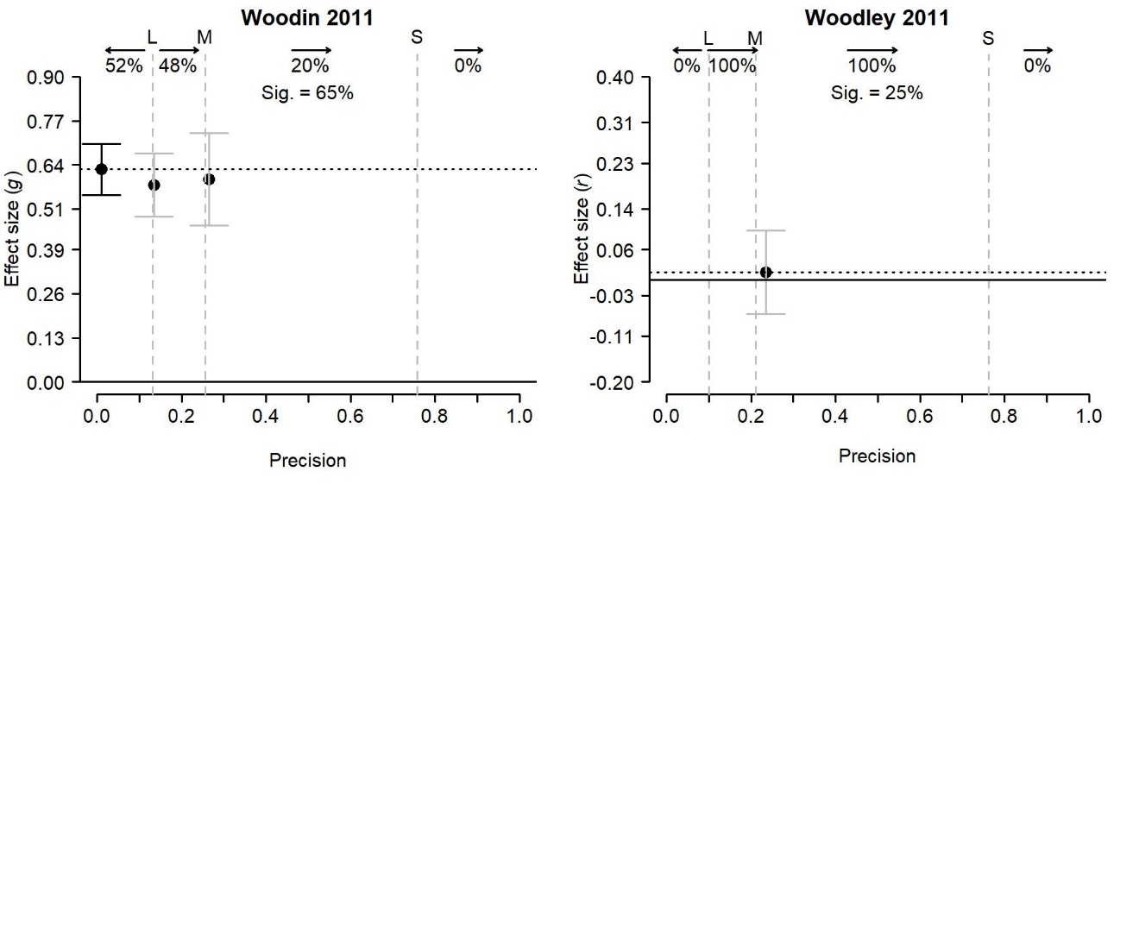

Figure 5. Summary meta-plots of the ten randomly sample meta-analyses.

*Alfieri et al. (2011)*

This meta-analysis based on 24 studies examined if enhanced and/or assisted discovery learning is associated with greater learning benefits compared to other types of instructional learning for children. Many studies had insufficient statistical power to detect a large true effect size (42%), few studies had sufficient statistical power to detect a medium true effect size (12%). The estimated average effect size was *g* = 0.213 (, *I2* = 42%)with its CI95 [0.091; 0.334] excluding 0, suggesting a positive association. Both the absence of a decreasing trend in the estimates of the cumulative meta-analysis and the low proportion of statistically significant primary effect sizes (33.3%) suggest that publication biasdid not affect the results of this meta-analysis. As the study with the largest precision (rightmost dot) also suggests an effect size equal to about .2, we see no reason to doubt the estimate and its CI95, and the inference that enhanced discovery learning is positively associated to greater learning benefits for children compared to other types of instructional learning.

*Benish et al. (2011)*

This meta-analysis based on 21 studies examined if culturally adapted psychotherapy is associated with better outcomes for mental illnesses than non-adapted bona fide psychotherapy for minority patients. Many studies had insufficient statistical power to detect a large true effect size (76%), and few studies had sufficient power to detect a large true effect size (24%). No studies had sufficient statistical power to detect a small or medium true effect size. The estimated average effect size was *g* = 0.362 ( 0, *I2* = 0%) with its CI95 [0.234; 0.49] excluding 0, suggesting a positive association. Both the absence of a distinct decreasing trend in the estimates of the cumulative meta-analysis and the low proportion of statistically significant primary effect sizes (23.8%) suggest that publication biasdid not affect the results of this meta-analysis. We therefore see no reason to doubt the estimate and its CI95, and the inference that culturally adapted psychotherapy is associated with better outcomes than non-adapted bona fide psychotherapy for minority patients.

*Berry et al. (2011)*

This meta-analysis based on 21 studies examined if counterproductive work behavior (CWB) reports that are filled out by colleagues provide extra information compared to self-reports of CWB. Most studies had sufficient statistical power to detect a true medium effect size (90%), and a few studies had statistical sufficient power to detect a large effect (10%). The estimated average effect size was *r* = .365 ( 0.04, *I2* = 86.6%) with its CI95 [.282; .444] excluding 0, suggesting a positive association. The meta-plot depicts a distinct decreasing trend in the estimates of the cumulative meta-analysis, indicating a small-study effect. As more than 80% of the effects were statistically significant (95.2%), the meta-plot also shows the effect sizes that are expected from a true zero effect size in combination with extreme publication bias (black stars). Since the effects estimated in the cumulative meta-analysis are consistently larger than what would be expected from a zero effect and extreme publication bias, we believe a positive association may indeed exist. However, as the meta-analyses incorporating only the larger studies provide a lower effect size estimate (*r* = .18 based on only the largest study, compared to *r* = .37 based on all studies), we recommend caution when interpreting the effect size estimate of the meta-analysis.

*Card et al (2011)*

This meta-analysis based on 11 studies investigated the association between military deployment and children’s externalizing symptoms. All studies had sufficient statistical power to detect a large true effect size, most had sufficient statistical power to detect a medium true effect size (73%), and only one study (9%) had sufficient power to detect a small true effect size. The estimated average effect size was *r* = .04 ( 0.028, *I2* = 84.8%) with its CI95 [-.07; .15 including 0, suggesting no association. As few primary studies’ effect size were statistically significant (9.1%) and the results of the cumulative meta-analyses are in line with a zero true effect size, we see no reason to doubt the estimate, its CI95, nor the conclusion of no association between military deployment and children’s externalizing symptoms.

*Farber and Doolin (2011)*

This meta-analysis based on 18 studies examined the association between therapists’ provision of positive regard and therapeutic outcome. Only few studies had sufficient statistical power to detect a medium true effect size (17%), whereas 72% had sufficient power to detect a large effect size. The estimated average effect was *r* = .266 ( 0.054, *I2* = 73.4%) with the CI95 [.135; .389] excluding 0, suggesting a positive relationship. However, as a decreasing trend is observed in the cumulative meta-analysis, and the effect size estimate based on only the studies with sufficient power to detect a medium effect size estimate (*r* = 0.151, CI95 from -0.045 to 0.335; see the summary meta-plot) is not significantly different from zero, we are not yet convinced by the evidence of a positive association between therapist’s positive regard and therapeutic outcome.

*Green & Rosenfeld (2011)*

The meta-analysis consists of 12 studies that investigate the efficacy of the structured interview of reported symptoms to identify feigning from genuine responders. The meta-plot shows that the majority of the studies did not have sufficient statistical power to detect a large effect size (67% of the studies), and the remaining 33% of the studies only had enough power to detect a large effect. The estimated average effect was about *g* = 1.782 (, *I2* = 48%), with CI95 [1.534; 2.03] excluding 0, suggesting a very large positive effect. As the meta-plot shows no decreasing trend, all primary studies’ effects were statistically significant, and the estimates of the cumulative meta-analysis are well above those expected from a true zero effect size in combination with extreme publication bias, we see no reason to doubt the estimate and its CI95, and the conclusion that structured interviews of reported systems are effective to identify feigning from genuine responders.

*Lucassen et al.(2011)*

This meta-analysis based on 16 studies examined if higher levels of paternal sensitivity are associated with more infant-father attachment security. All of the studies in the meta-analysis had sufficient statistical power to detect a large true effect size, half of the studies had sufficient power to detect a medium true effect size, and none of the studies had sufficient power to detect a small true effect size. The estimated average effect size was about *r* = .12 (, *I2* = 0%) with its CI95 [.066; .173] excluding 0, suggesting a positive association. Both the absence of a decreasing trend in the estimates of the cumulative meta-analysis and the low proportion of statistically significant primary effect sizes (18.8%) suggest that publication biasdid not affect the results of this meta-analysis. As the most precise studies also consistently provide evidence of a small effect, we deem it indeed plausible that there is a small true effect of paternal sensitivity on infant-father attachment security.

*Mol & Bus (2011)*

This meta-analysis based on 18 studies examined the association between print exposure and basic reading skills among children in grades 1-12. Many studies in the meta-analysis had insufficient statistical power to detect a large true effect size (72%), one third of the studies had sufficient power to detect a medium true effect size, and none of the studies had sufficient power to detect a small true effect size. The estimated average effect size was *r* = .254 (= 0.003, *I2* = 15.7%) with its CI95 [.191; .314] excluding 0, suggesting a positive association. Noteworthy is that 44.4% of primary studies’ effect sizes were statistically significant despite their low statistical power to detect a small effect size. As there is a slight decreasing trend in the estimates of the cumulative meta-analysis and the effect is smallest in the two most precise studies compared to the others, we believe the meta-analysis does not provide very convincing evidence of an association between print exposure and basic reading skills among children.

*Woodlin (2011)*

This meta-analysis contained 40 studies examining the relation between relationship satisfaction and hostility; 52% of studies had insufficient power to detect a large effect, whereas 20% and 0% had sufficient power to detect a medium and small effect, respectively. The average effect size was negative with *g* = 0.627 (=0.003, *I2* = 4.3%) with its CI95 [0.551; 0.702] excluding 0.[8] The meta-plot does not show a clear decreasing trend, and quite some statistically non-significant effect sizes are present in the meta-analysis (35%). As a result, we see no reason to doubt the association between hostility and lower relationship satisfaction.

*Woodley (2011)*

This meta-analysis examined the relation between measures of life history speed and intelligence. It contained 12 independent effect sizes, originating from 10 different studies. None of the studies had sufficient statistical power to detect a small effect, while all (100%) of the studies had sufficient power to detect a medium effect. The average effect size was *r* = .016 (, *I2* = 71.4%), with its CI95 [-.067; .098] including 0, suggesting no association. The absence of a decreasing trend in the meta-plot and the small percentage of statistically significant primary studies’ effects (25%) suggest that this meta-analysis is not affected by publication bias. Notably, the effect size of a meta-analysis based on the two studies with the largest sample size (both 239) was also statistically significant (*r* = .185, CI95 [.097; .27]). Based on these results we do not believe that the meta-analytic results are affected by publication bias, and conclude that if an association exists between life history speed and intelligence then it is likely small.

**Software for creating a meta-plot**

Meta-plots can currently be created for three effect size measures: standardized mean difference based on two independent groups (Hedges *g*), Pearson correlation coefficient, and odds ratio (see Appendix A). The function “meta_plot()” in the R package “puniform” (Van Aert, 2019) can be used for creating a meta-plot. The function’s input concerning primary studies depends on the effect size measure. In case of standardized mean differences, the user has to specify means, standard deviations, and sample sizes for both groups. For correlation coefficients sample size and sample correlation coefficient are needed. For odds ratios the cell frequencies of a 2x2 frequency table are required. By default a meta-plot is drawn based on all effect sizes in a meta-analysis, but a summary meta-plot can be created by specifying the argument “nr_lines = “summary”” in the “meta_plot()” function.

We also developed a user-friendly web application (<https://rvanaert.shinyapps.io/meta-plot/>) to create meta-plots for researchers who are not familiar with R. Figure 6 shows a screenshot of this web application. The same information as in the “meta_plot()” function has to be specified, but using a web browser and a graphical user interface. Data can be entered in a table, or uploaded via a comma separated file that follows a specific format as explained in the manual of the web application. If the data are loaded in the web application, the meta-plot and summary meta-plot are created by clicking the button (“Create plots”), and these plots can also be downloaded as a pdf file (“Download plots” button).

Figure 6. Screenshot of the web application of meta-plot after applying meta-plot to the meta-analysis of Rabelo et al. (2015).

**Discussion**

This paper presents, explains and illustrates meta-plot, a user-friendly graphical tool for meta-analysis. The goal of the meta-plot is to assist in the interpretation of meta-analytic results in the context of the field and the primary studies’ effect sizes on which the meta-analysis is based. The meta-plot contains information on the statistical power of the primary studies, statistical significance of the primary study effect sizes, and the random-effects estimate of the average effect size including its 95% confidence interval. It also contains the results of a cumulative meta-analysis with respect to precision, yielding a robustness check of the meta-analytic effect size with respect to primary studies’ precision as well as evidence of small-study effects and publication bias. Because of providing these useful pieces of information we recommend using the meta-plot in addition to any meta-analysis of common effect size measures, replacing and in our opinion improving greatly upon the funnel plot.

One problem of meta-analyses is the interpretation of small-study effects (Sterne et al., 2011), as signaled by a decreasing trend in the meta-plot. The meta-plot helps with interpreting small-study effects using the percentage of statistically significant primary effect sizes; a low percentage of statistically significant results cannot go together with strong publication bias. All of the meta-analyses with clear evidence of a small-study effect in our paper (the two cherry-picked examples, and Berry et al. (2011), that is, three out of twelve meta-analyses) have more than 90% significant effect sizes, suggesting that publication bias may be the cause of the small-study effects. The two cherry-picked examples illustrate that small-study effects can be fully explained by publication bias, and that heterogeneity of effect sizes is not needed to explain the results. Publication bias also explains at least part of the decreasing trend in Berry et al., but the trend may also reflect heterogeneity of effect size as the cumulative meta-analysis shows that small studies yielded relatively large effect sizes.

These three examples also show how publication bias, average effect size, and heterogeneity of effect size may interact in complex ways (Augusteijn et al., 2019; Jackson, 2006), and suggest that statistics is not the be-all and end-all when interpreting the small-study effect. We recommend examining the designs and studies that gave rise to the primary study effect sizes. Meta-analyses in psychology typically report large heterogeneity (Van Erp et al., 2017) probably because they incorporate studies with widely varying designs, variables, and measures, whereas meta-analyses of multi-lab direct replication studies mostly find no heterogeneity and seldom substantial heterogeneity (Klein et al., 2018; Olsson Collentine et al, 2020). Hence, small-study effects are less likely to be caused by heterogeneity in meta-analyses of very similar studies than when the meta-analysis includes studies that may differ in many respects.

The meta-plot also has some limitations. First, the meta-plot provides no useful information on two important elements of the meta-analysis; heterogeneity of effect sizes and possible moderator effects. The meta-plot is a graphical tool providing information on the average effect size estimate, including a robustness check and a check if publication bias may alternatively explain this average estimate. For assessing heterogeneity and how its assessment is affected by and robust to publication bias we refer to the *Q*-plot (Augusteijn et al., 2019). Moderator effects are, in our opinion, best assessed and tested using statistics rather than using a graphical tool, although the meta-plot can also be applied to a subset of studies based on scores on a moderator. A second limitation is that the meta-plot currently can only be applied to common effect size measures Hedges’ *g*, Pearson’s correlation, and the odds ratio. Extension to other effect size measures is future research. Third, the meta-plot only examines the possible effect of publication bias where this bias is the unidirectional suppression of statistically nonsignificant effect sizes. Evidence of other types of publication bias cannot be detected with the meta-plot because these types do not result in a specific trend in the effect size estimates of the cumulative meta-analysis. Finally, the meta-plot does not include statistical tests in addition to those of cumulative meta-analysis. However, this is by design; as tests often make strong assumptions and have limited power, we chose not to incorporate statistical tests in the meta-plot.

Although we believe the meta-plot has substantial added value to a meta-analysis in its own right, the meta-plot may also assist in meta-research. Meta-research is the study of research itself: its methods, reporting, reproducibility, evaluation, and incentives (Ioannidis, 2018). Output of the meta-plot directly provides information on statistical power and statistical significance of research in different fields or disciplines. For instance, concerning power, the meta-plots of the ten randomly selected meta-analyses from psychology reveal that seven (70%) meta-analyses contain a substantial percentage (28% or more) of studies with insufficient power (less than 80%) to detect a large true effect size, and only one (10%) meta-analysis contains at least one study with sufficient power to detect a small true effect size. Output of meta-plot like this can be further used to analyze the statistical power of studies as a function of field or journal.

The meta-plot also provides essential input for analyses of statistical significance of primary studies and the related issue of publication bias. The literature suggests that around 95% of main results are statistically significant in papers in psychology (Fanelli, 2012), and this was even higher in the flagship journal *Psychological Science* (Francis, 2014). However, these findings starkly contrast with the results of our 10 meta-plots; the median and average number of statistically significant findings are 44.4% and 46.8%, respectively, and only 2 (20%) contain at least 95% significant findings. Our findings are in line with a large review of meta-analyses in Psychological Bulletin (2004-2014), which found that 28.9% of 3,398 primary study effect sizes in meta-analyses were statistically significant (Van Aert et al., 2019). We believe this large disparity between primary study findings in meta-analyses and main results in papers is explained by biases operating on the main result of a paper, but that meta-analyses often also include effect sizes that are of secondary importance in their paper and therefore not or less affected by biases. This reasoning suggests the need for another assessment or test of bias (i.e., publication bias or other biases related to statistical significance), which compares the average effect size of studies where the effect was a primary outcome to the average effect size of studies where it was not.

In summary, we have developed a new user-friendly graphical tool for meta-analysis that assists the meta-analyst in interpreting the results of the meta-analysis. It provides succinct information on statistical power and the significance of primary studies, as well as the results of random-effects meta-analyses and several sensitivity analyses. As the meta-plot fills a similar role to the funnel plot in meta-analytic research but is less subjective and (much) more informative, meta-analysts should consider exchanging the funnel plot for the meta-plot.

**Appendix A1: A study’s precision and the *x*-axis of the meta-plot**

The *x*-axis of the meta-plot represents a sample size equivalent, and is approximately linear in the precision of the study’s effect size, where precision is defined as the reciprocal of the effect size’s standard error. The maximum value on *x* in the plot, *xmax*, is (close to) that sample size or sample size equivalent that corresponds to a statistical power of 95% to detect a small population effect size. In the paragraphs below, we explain how we calculated the precision for different study designs.

*Correlation coefficient*

A study’s precision equals $\sqrt{N-3}$, using the scale of Fisher-transformed correlation coefficients. As 1,293 observations are needed for a power of 95% to detect a small true effect size using a two-tailed test, we set *xmax* = 1,300. When setting *xmin* = 4 for a sample size of 4, we obtain a scale that is approximately linear in precision if a study’s relative position (from 0 to 1) on the *x*-axis is calculated as

$$x=\frac{\sqrt{N}-2}{\sqrt{1300}-2},$$

which means that the *x*-axis is on a square-root scale. Studies with a sample size larger than 1300 also receive *x* = *xmax*.

*Standardized mean difference*

In a balanced study with equal group sizes (*n1* = *n2*),1,302 observations are needed to achieve a statistical power of 95% to detect a small true effect size with a two-tailed test. Hence, we also set *xmin* = 4 and *xmax* = 1,300 for standardized mean differences. A study’s relative position (from 0 to 1) on the *x*-axis is calculated as

$$x=\frac{\sqrt{\frac{n_{1}n_{2}}{n_{1}+n_{2}}}-\sqrt{2}}{\sqrt{325}-\sqrt{2}}.$$

Here, $\sqrt{\frac{n_{1}n_{2}}{n_{1}+n_{2}}}$ reflects the precision of the study, as an effect size’s standard error is linear in this term. The denominator reflects the difference between $\sqrt{\frac{n_{1}n_{2}}{n_{1}+n_{2}}}$ for balanced studies with *N* = *xmax* = 1,300 and *N* = *xmin* = 4. As a study’s precision is maximal for a balanced design, studies’ positions are not necessarily monotonically related to their total sample sizes. For instance, a balanced study with *N* = 400 yields relative position *x* = 0.517 whereas a larger study with *n1* = 400 and *n2* = 100 (*N* = 500) yields *x* = 0.453, which is equal to the *x-*value of a balanced study with *N* = 320. For interpretation purposes, values on the *x*-axis are linked to total sample sizes of balanced studies yielding those *x*-values.

*Odds ratio*

For meta-analyses on binary criterion variables we choose the odds ratio (OR) as effect size measure. First, we determine the value of the OR corresponding to a small, medium, and large effect size. We follow Chen et al. (2010) by linking these effect sizes to small, medium, and large values of Cohen’s *d*. Chen et al. showed, for instance, that OR =1.68 is equivalent to *d* = 0.2 if the base rate proportion is 0.01. The complication is that the base rate affects the value of the OR that is equivalent to *d* = 0.2. Consequently, for the meta-plot we first have to determine the base rate proportion *πC*. By default the program calculates this proportion as the estimate of a random-effects model with the Paule-Mandel as estimator for the between-study variance based on the control conditions of all studies.

Second, from *πC* we derive the proportion *πE* in the experimental condition that is equivalent to a value of Cohen’s *d* by $π_{E}=Φ(Φ^{-1}\left(pπ_{C}\right)+d)$, with $Φ$ denoting the cumulative normal distribution. For instance, for a small effect and *πC* = 0.10 we obtain ${pπ}_{E}=Φ\left(-1.28155+0.2\right)=$ 0.1397. These values of *πC* and *πE* correspond to OR = 1.4618. Similarly, for *πC* = 0.10 we obtain medium and large effect sizes of OR = 2.4978 and OR = 4.1399, respectively.

In the third step, we determine the precision that yields a 95% power of detecting a small true effect size using a two-tailed test. For that we use a two-tailed *z*-test with *α*= .05, with

$$z=\frac{ln⁡(OR)}{\sqrt{\frac{1}{A}+\frac{1}{B}+\frac{1}{C}+\frac{1}{D}}},$$

where the denominator is the precision with *A*, *B*, *C*, *D* denoting the cell frequencies + 0.5 (Leucht et al., 2012). The precision required for a power of 95% to detect a small effect then equals 3.6048/ln(ORsmall), with ORsmall being calculated from *πC* and *πE* in the second step, which also equals *xmax*. The precisions required for a power of 80% to obtain a small, medium, large effect size are 2.8016/ln(ORsmall), 2.8016/ln(ORmedium), 2.8016/ln(ORlarge), respectively.

Finally, each study’s position on the *x*-axis is calculated using the denominator of the *z*-test. A study’s relative position equals

$$x=\frac{\frac{1}{\sqrt{\frac{1}{A}+\frac{1}{B}+\frac{1}{C}+\frac{1}{D}}}-\frac{1}{\sqrt{\frac{4}{2.5}}}}{\frac{3.6048}{ln⁡(1.4618)-}\frac{1}{\sqrt{\frac{4}{2.5}}}},$$

with *xmin* = = 0.7906, which is obtained for a study with a cell frequency of 2 in each cell. Again, studies with *x* > 1 get *x* = 1. As many and very different cell frequencies may result in the same precision, the *x*-axis is not labelled with sample sizes but by precision itself. The meta-plot also depicts the values of ORsmall, ORmedium, and ORlarge.

To continue our example with *πC* = 0.10, we already saw that ORsmall = 1.4618. A precision of *xmax* = 3.6048/ln(1.4618) = 9.4946 is required to obtain a power of 95% to detect a true small effect size. The relative position of a study with 80% power to detect ORsmall is then

$$x=\frac{\frac{2.8016}{ln⁡(1.4618)-}\frac{1}{\sqrt{\frac{4}{2.5}}}}{\frac{3.6048}{ln⁡(1.4618)-}\frac{1}{\sqrt{\frac{4}{2.5}}}}=0.7569.$$

Similarly, for ORmedium and ORlarge and a power of 80% we obtain relative positions 0.2608 and 0.1357, respectively.

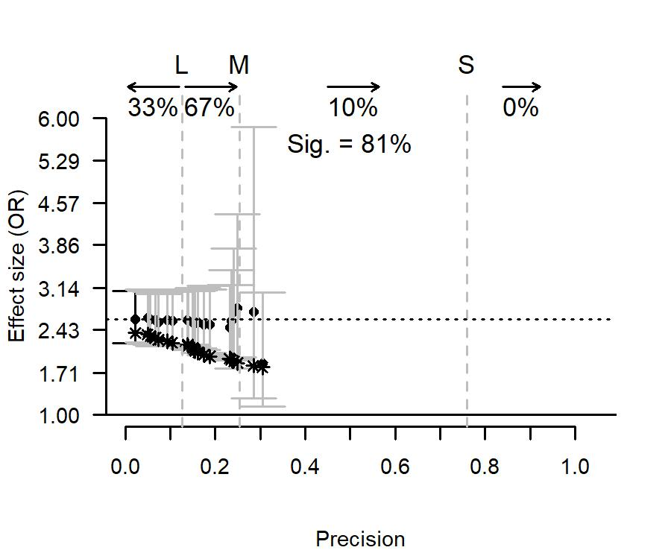

Figure A1. Meta-plot of Leucht et al. (2012) with OR as effect size measure.

As the main text of our paper does not contain an example of a meta-plot with odds ratio as effect size measure, we illustrate it here by randomly sampling a meta-analysis with odds ratio from the data set used in Van Aert et al. (2019),10 with the provision that it contained at least 15 primary studies. The sampled meta-analysis of Walter and Cook (1991) was a subset of 21 industry sponsored studies on the efficacy for treating major depressive disorder with amitriptyline. Figure A1 shows the meta-plot of this meta-analysis. The average effect size was OR = 2.661 (, *I2* = 0%), with its CI95 [2.246; 3.152] excluding 0, implying that the treatment was efficacious. 33% of the primary studies had sufficient statistical power to detect a large effect and 67% of the primary studies had sufficient statistical power to detect at least an effect of medium size. The percentage of statistically significant primary studies was 81%, so black stars indicating extreme publication bias in combination with no effect are also shown in the meta-plot. The black dots are above the black stars, so we conclude that true effect is likely larger than zero.

**Appendix A2: Computing the expected results based on a zero true effect in combination with extreme publication bias**

A cumulative meta-analysis is carried out with studies’ effect sizes substituted by their expected value based on a true effect size equal to zero in combination with extreme publication bias (i.e., only statistically significant effect sizes entered the meta-analysis). When the effect size measure is the Fisher-transformed correlation, this expected value equals

$$\sqrt{\frac{1}{N-3}}×40×φ(Φ^{-1}(.975))$$

The first term equals the standard error of the Fisher-transformed correlation, whereas the remainder represents the so-called Mills ratio, which is the expected value of the upper part (here the 2.5%) of the standard normal distribution. Symbols $φ$ and $Φ$ represent the probability density and cumulative distribution function of the normal distribution, respectively, and .975 the relevant percentile of the normal distribution.

When the effect size measure is Cohen’s *d* or Hedges’ *g*, the expected value equals

$$\sqrt{\frac{n_{1}+n_{2}}{n_{1}n_{2}}}×\sqrt{\frac{n_{1}+n_{2}-2}{n_{1}+n_{2}-4}}×J×40×φ(Φ^{-1}(.975))$$

where

$$J= \frac{Γ\left(\frac{m}{2}\right)}{\sqrt{\frac{m}{2}}Γ\left(\frac{m-1}{2}\right)}$$

with Γ being the gamma function and *m* the degrees of freedom (i.e., $n_{1}+n_{2}-2$). In the formula for the expected value, we recognize Mill’s ratio to the right. The first three terms equal the square root of the exact variance of Hedges’ *g* when the true effect size equals 0 (see Equation (22) in Viechtbauer, 2007). The first term can be recognized as the square root of the inverse of a study’s evidential value as defined in Appendix A1, whereas the second and third term are “corrections” for bias in the calculation of the exact variance of Hedges’ *g* (Viechtbauer, 2007).

Finally, for meta-analysis on the odds ratio the expected value equals

$\sqrt{\frac{1}{A}+\frac{1}{B}+\frac{1}{C}+\frac{1}{D}}×40×φ(Φ^{-1}(.975))$.

We use fixed-effect meta-analysis to compute the expected effect sizes in the cumulative meta-analysis, since the model assumes a zero true effect size. The weights used in a fixed-effect meta-analysis to compute the estimated average effect size equal the reciprocal of the squared standard error of the estimates. The standard errors for correlation and standardized mean differences are already presented in the formulas above. Note that the standard error of the estimate based on the 2.5% upper percentile of the standard normal distribution is actually a fraction (much smaller than 1) of the standard error of the complete distribution. But since this fraction is the same for all studies, it cancels out in the computation of the average expected estimate.

**References**

Aberson, C. L. (2011). *Applied power analysis for the behavioral sciences*. New York, NY: Routledge.

Aguinis, H., Dalton, D. R., Bosco, F. A., Pierce, C. A., & Dalton, C. M. (2010). Meta-analytic choices and judgment calls: Implications for theory building and testing, obtained effect sizes, and scholarly impact. *Journal of Management, 37*(1), 5-38. doi:10.1177/0149206310377113

Alfieri, L., Brooks, P. J., Aldrich, N. J., & Tenenbaum, H. R. (2011). Does discovery-based instruction enhance learning? *Journal of Educational Psychology, 103*(1), 1-18. doi:10.1037/a0021017

Atakpo, P., & Vassar, M. (2016). Cumulative meta-analysis by precision as a method to evaluate publication bias. *Journal of Dermatological Science, 83*(3), 251-253. doi:10.1016/j.jdermsci.2016.06.001

Augusteijn, H. E. M., van Aert, R. C. M., & van Assen, M. A. L. M. (2019). The effect of publication bias on the Q test and assessment of heterogeneity. *Psychological Methods, 24*(1), 116-134. doi:10.1037/met0000197

Bakker, M., van Dijk, A., & Wicherts, J. M. (2012). The rules of the game called psychological science. *Perspectives on Psychological Science, 7*(6), 543-554. doi:10.1177/1745691612459060

Begg, C. B., & Mazumdar, M. (1994). Operating characteristics of a rank correlation test for publication bias. *Biometrics, 50*(4), 1088-1101.

Benish, S. G., Quintana, S., & Wampold, B. E. (2011). Culturally adapted psychotherapy and the legitimacy of myth: A direct-comparison meta-analysis. *Journal of Counseling Psychology, 58*(3), 279-289. doi:10.1037/a0023626

Berry, C. M., Carpenter, N. C., & Barratt, C. L. (2012). Do other-reports of counterproductive work behavior provide an incremental contribution over self-reports? A meta-analytic comparison. *Journal of Applied Psychology, 97*(3), 613-636. doi:10.1037/a0026739

Borenstein, M., Hedges, L. V., Higgins, J. P. T., & Rothstein, H. R. (2009). *Introduction to meta-analysis*. Chichester, UK: John Wiley & Sons, Ltd.

Button, K. S., Ioannidis, J. P., Mokrysz, C., Nosek, B. A., Flint, J., Robinson, E. S., & Munafò, M. R. (2013). Power failure: Why small sample size undermines the reliability of neuroscience. *Nature Reviews Neuroscience, 14*(5), 365-376. doi:10.1038/nrn3475

Card, N. A., Bosch, L., Casper, D. M., Wiggs, C. B., Hawkins, S. A., Schlomer, G. L., & Borden, L. M. (2011). A meta-analytic review of internalizing, externalizing, and academic adjustment among children of deployed military service members. *Journal of Family Psychology, 25*(4), 508-520. doi:10.1037/a0024395

Carter, E. C., Schönbrodt, F. D., Gervais, W. M., & Hilgard, J. (2019). Correcting for bias in psychology: A comparison of meta-analytic methods. *Advances in Methods and Practices in Psychological Science, 2*(2), 115-144. doi:10.1177/2515245919847196

Chen, H., Cohen, P., & Chen, S. (2010). How big is a big odds ratio? Interpreting the magnitudes of odds ratios in epidemiological studies. *Communications in Statistics, 39*(4), 860-864. doi:10.1080/03610911003650383

Cohen, J. (1988). *Statistical power analysis for the behavioral sciences* (2nd ed.). Hillsdale, NJ: Lawrence Erlbaum Associates.

Duval, S., & Tweedie, R. L. (2000a). A nonparametric "trim and fill" method of accounting for publication bias in meta-analysis. *Journal of the American Statistical Association, 95*(449), 89-98. doi:10.1080/01621459.2000.10473905

Duval, S., & Tweedie, R. L. (2000b). Trim and fill: A simple funnel-plot-based method of testing and adjusting for publication bias in meta-analysis. *Biometrics, 56*(2), 455-463.

Egger, M., Smith, G. D., Schneider, M., & Minder, C. (1997). Bias in meta-analysis detected by a simple, graphical test. *British Medical Journal, 315*, 629-634.

Ellis, P. D. (2010). *The essential guide to effect sizes: An introduction to statistical power, meta-analysis, and the interpretation of research results*. Cambridge, UK: Cambridge University Press.

Fanelli, D. (2010). “Positive” results increase down the hierarchy of the sciences. *PLOS ONE, 5*(4), e10068. doi:10.1371/journal.pone.0010068

Fanelli, D. (2012). Negative results are disappearing from most disciplines and countries. *Scientometrics, 90*(3), 891-904. doi:10.1007/s11192-011-0494-7

Fanelli, D., Costas, R., & Ioannidis, J. P. (2017). Meta-assessment of bias in science. *Proc Natl Acad Sci USA*. doi:10.1073/pnas.1618569114

Farber, B. A., & Doolin, E. M. (2011). Positive regard. *Psychotherapy, 48*(1), 58-64. doi:10.1037/a0022141

Ferguson, C. J., & Brannick, M. T. (2012). Publication bias in psychological science: Prevalence, methods for identifying and controlling, and implications for the use of meta-analyses. *Psychological Methods, 17*(1), 120-128. doi:10.1037/a0024445

Francis, G. (2014). The frequency of excess success for articles in Psychological Science. *Psychonomic Bulletin & Review, 21*(5), 1180-1187. doi:10.3758/s13423-014-0601-x

Green, D., & Rosenfeld, B. (2011). Evaluating the gold standard: A review and meta-analysis of the structured interview of reported symptoms. *Psychological Assessment, 23*(1), 95-107. doi:10.1037/a0021149

Hallion, L. S., & Ruscio, A. M. (2011). A meta-analysis of the effect of cognitive bias modification on anxiety and depression. *Psychological Bulletin, 137*(6), 940-958. doi:10.1037/a0024355

Hedges, L. V., & Vevea, J. L. (1998). Fixed- and random-effects models in meta-analysis. *Psychological Methods, 3*(4), 486-504.

Hedges, L. V., & Vevea, J. L. (2005). Selection method approaches. In H. R. Rothstein, A. J. Sutton, & M. Borenstein (Eds.), *Publication bias in meta-analysis: Prevention, assessment, and adjustments*. Chichester: UK: Wiley.

Hunter, J. E., & Schmidt, F. L. (2000). Fixed effects vs. random effects meta-analysis models: Implications for cumulative research knowledge. *International Journal of Selection and Assessment, 8*(4), 275-292.

Ioannidis, J. P. (2008). Why most discovered true associations are inflated. *Epidemiology, 19*(5), 640-648. doi:10.1097/EDE.0b013e31818131e7

Ioannidis, J. P. A. (2018). Meta-research: Why research on research matters. *PLOS Biology, 16*(3). doi:10.1371/journal.pbio.2005468

Jackson, D. (2006). The implications of publication bias for meta-analysis' other parameter. *Statistics in Medicine, 25*(17), 2911-2921. doi:10.1002/sim.2293

John, L. K., Loewenstein, G., & Prelec, D. (2012). Measuring the prevalence of questionable research practices with incentives for truth telling. *Psychological Science, 23*(5), 524-532. doi:10.1177/0956797611430953

Klein, R. A., Vianello, M., Hasselman, F., Adams, B. G., Adams, R. B., Alper, S., . . . Nosek, B. A. (2018). Many Labs 2: Investigating variation in replicability across samples and settings. *Advances in Methods and Practices in Psychological Science, 1*(4), 443-490. doi:10.1177/2515245918810225

Kraemer, H. C., Gardner, C., Brooks, J., & Yesavage, J. A. (1998). Advantages of excluding underpowered studies in meta-analysis: Inclusionist versus exclusionist viewpoints. *Psychological Methods, 3*(1), 23-31. doi:10.1037/1082-989X.3.1.23

Langan, D., Higgins, J. P. T., & Simmonds, M. (2016). Comparative performance of heterogeneity variance estimators in meta-analysis: A review of simulation studies. *Research Synthesis Methods, 8*(2), 181-198. doi:10.1002/jrsm.1198

Lau, J., Ioannidis, J. P. A., Terrin, N., Schmid, C. H., & Olkin, I. (2006). The case of the misleading funnel plot. *BMJ, 333*(7568), 597-600. doi:10.1136/bmj.333.7568.597

Leimu, R., & Koricheva, J. (2004). Cumulative meta-analysis: A new tool for detection of temporal trends and publication bias in ecology. *Proceedings Royal Society of London. Biological Sciences, 271*(1551), 1961-1966. doi:10.1098/rspb.2004.2828

Leucht, C., Huhn, M., & Leucht, S. (2012). Amitriptyline versus placebo for major depressive disorder. *Cochrane Database of Systematic Reviews*(12). doi:10.1002/14651858.CD009138.pub2

Levine, T., Asada, K., & Carpenter, C. (2009). Sample sizes and effect sizes are negatively correlated in meta-analyses: Evidence and implications of a publication bias against nonsignificant findings. *Communication Monographs, 76*(3), 286-302.

Light, R. J., & Pillemer, D. B. (1984). *Summing up: The science of reviewing research*. Cambridge, MA: Harvard University Press.

Lucassen, N., Tharner, A., Van IJzendoorn, M. H., Bakermans-Kranenburg, M. J., Volling, B. L., Verhulst, F. C., . . . Tiemeier, H. (2011). The association between paternal sensitivity and infant-father attachment security: A meta-analysis of three decades of research. *Journal of Family Psychology, 25*(6), 986-992. doi:10.1037/a0025855

McCall, R. B., & Carriger, M. S. (1993). A meta-analysis of infant habituation and recognition memory performance as predictors of later IQ. *Child Development, 64*(1).

McShane, B. B., Böckenholt, U., & Hansen, K. T. (2016). Adjusting for publication bias in meta-analysis: An evaluation of selection methods and some cautionary notes. *Perspectives on Psychological Science, 11*(5), 730-749. doi:10.1177/1745691616662243

Mol, S. E., & Bus, A. G. (2011). To read or not to read: A meta-analysis of print exposure from infancy to early adulthood. *Psychological Bulletin, 137*(2), 267-296. doi:10.1037/a0021890

Nuijten, M. B., van Assen, M. A. L. M., Veldkamp, C. L. S., & Wicherts, J. M. (2015). The replication paradox: Combining studies can decrease accuracy of effect size estimates. *Review of General Psychology, 19*(2), 172-182. doi:10.1037/gpr0000034

Olsson-Collentine, A., Wicherts, J. M., & van Assen, M. A. L. M. (2020). Heterogeneity in direct replications in psychology and its association with effect size. *Psychological Bulletin, 146*(10), 922-940. doi:10.1037/bul0000294

Open Science Collaboration. (2015). Estimating the reproducibility of psychological science. *Science, 349*(6251). doi:10.1126/science.aac4716

Paule, R. C., & Mandel, J. (1982). Consensus values and weighting factors. *Journal of Research of the National Bureau of Standards, 87*(5), 377-385.

Peters, J. L., Sutton, A. J., Jones, D. R., Abrams, K. R., & Rushton, L. (2008). Contour-enhanced meta-analysis funnel plots help distinguish publication bias from other causes of asymmetry. *Journal of Clinical Epidemiology, 61*(10), 991-996. doi:10.1016/j.jclinepi.2007.11.010

Rabelo, A. L. A., Keller, V. N., Pilati, R., & Wicherts, J. M. (2015). No effect of weight on judgments of importance in the moral domain and evidence of publication bias from a meta-analysis. *PLOS ONE, 10*(8), e0134808. doi:10.1371/journal.pone.0134808

Rice, K., Higgins, J. P. T., & Lumley, T. (2018). A re-evaluation of fixed effect(s) meta-analysis. *RSSA Journal of the Royal Statistical Society: Series A 181*(1), 205-227. doi:10.1111/rssa.12275

Simonsohn, U., Nelson, L. D., & Simmons, J. P. (2014). P-curve and effect size: Correcting for publication bias using only significant results. *Perspectives on Psychological Science, 9*(6), 666-681. doi:10.1177/1745691614553988

Stanley, T. D., & Doucouliagos, H. (2014). Meta-regression approximations to reduce publication selection bias. *Research Synthesis Methods, 5*(1), 60-78.

Stanley, T. D., Jarrell, S. B., & Doucouliagos, H. (2010). Could it be better to discard 90% of the data? A statistical paradox. *The American Statistician, 64*(1), 70-77. doi:10.1198/tast.2009.08205

Sterne, J. A. C., Gavaghan, D., & Egger, M. (2000). Publication and related bias in meta-analysis: Power of statistical tests and prevalence in the literature. *Journal of Clinical Epidemiology, 53*(11), 1119-1129. doi:10.1016/S0895-4356(00)00242-0

Sterne, J. A. C., Harbord, R. M., Sutton, A. J., Jones, D. R., Ioannidis, J. P., Terrin, N., . . . Higgins, J. P. T. (2011). Recommendations for examining and interpreting funnel plot asymmetry in meta-analyses of randomised controlled trials. *British Medical Journal, 343*(7818), 1-8. doi:http://dx.doi.org/10.1136/bmj.d4002

Tang, J.-L., & Liu, J. L. Y. (2000). Misleading funnel plot for detection of bias in meta-analysis. *Journal of Clinical Epidemiology, 53*(5), 477-484. doi:10.1016/S0895-4356(99)00204-8

Terrin, N., Schmid, C. H., & Lau, J. (2005). In an empirical evaluation of the funnel plot, researchers could not visually identify publication bias. *Journal of Clinical Epidemiology, 58*(9), 894-901. doi:10.1016/j.jclinepi.2005.01.006

van Aert, R. C. M. (2020). puniform: Meta-analysis methods correcting for publication bias. (Version 0.2.3). Retrieved from https://CRAN.R-project.org/package=puniform

van Aert, R. C. M., & Jackson, D. (2018). Multistep estimators of the between-study variance: The relationship with the Paule-Mandel estimator. *Statistics in Medicine, 37*(17), 2616-2629. doi:10.1002/sim.7665

van Aert, R. C. M., Wicherts, J. M., & van Assen, M. A. L. M. (2016). Conducting meta-analyses on p-values: Reservations and recommendations for applying p-uniform and p-curve. *Perspectives on Psychological Science, 11*(5), 713-729. doi:10.1177/1745691616650874

van Aert, R. C. M., Wicherts, J. M., & van Assen, M. A. L. M. (2019). Publication bias examined in meta-analyses from psychology and medicine: A meta-meta-analysis. *PLOS ONE, 14*(4). doi:10.1371/journal.pone.0215052

van Assen, M. A. L. M., van Aert, R. C. M., & Wicherts, J. M. (2015). Meta-analysis using effect size distributions of only statistically significant studies. *Psychological Methods, 20*(3), 293-309. doi:10.1037/met0000025

Van Erp, S. J., Verhagen, J., Grasman, R. P. P. P., & Wagenmakers, E.-J. (2017). Estimates of between-study heterogeneity for 705 meta-analyses reported in Psychological Bulletin from 1990-2013. *Journal of Open Psychology Data, 5*(1). doi:10.5334/jopd.33

Veroniki, A. A., Jackson, D., Viechtbauer, W., Bender, R., Bowden, J., Knapp, G., . . . Salanti, G. (2016). Methods to estimate the between-study variance and its uncertainty in meta-analysis. *Research Synthesis Methods, 7*(1), 55-79. doi:10.1002/jrsm.1164

Vevea, J. L., & Hedges, L. V. (1995). A general linear model for estimating effect size in the presence of publication bias. *Psychometrika, 60*(3), 419-435. doi:10.1007/bf02294384

Viechtbauer, W. (2007). Approximate confidence intervals for standardized effect sizes in the two-independent and two-dependent samples design. *Journal of Educational and Behavioral Statistics, 32*(1), 39-60. doi:10.3102/1076998606298034

Viechtbauer, W. (2010). Conducting meta-analyses in R with the metafor package. *Journal of Statistical Software, 36*(3), 1-48. doi:10.18637/jss.v036.i03

Walter, S. D., & Cook, R. J. (1991). A comparison of several point estimators of the odds ratio in a single 2 x 2 contingency table. *Biometrics, 47*(3), 795-811. doi:10.2307/2532640

Wilkinson, L. (1999). Statistical methods in psychology journals: Guidelines and explanations. *American Psychologist American Psychologist, 54*(8), 594-604. doi:10.1037//0003-066X.54.8.594

Woodin, E. M. (2011). A two-dimensional approach to relationship conflict: Meta-analytic findings. *Journal of Family Psychology, 25*(3), 325-335. doi:10.1037/a0023791

Woodley, M. A. (2011). The cognitive differentiation-integration effort hypothesis: A synthesis between the fitness indicator and life history models of human intelligence. *Review of General Psychology, 15*(3), 228-245. doi:10.1037/a0024348

1. Often precision is also defined as the reciprocal of the squared standard error. The advantage of defining precision as 1/SE is explained later in footnote 3.
2. If the true effect equals zero, statistical power is not defined. As one does not know the true effect size to be estimated in the meta-analysis, we believe it is essential to speak of the “precision of the research summarized in the meta-analysis” rather than the “power of research summarized in the meta-analysis”.
3. The standard error of the estimate of the (Fisher-*z* transformed) correlation is approximately *N*, and of the comparison of two independent population means it is approximately equal to (n1×n2)/(n1+n2) (see Appendix A2). Studies’ position on the *x*-axis is calculated using these approximations of their standard error. Consequently, if we have three studies A, B, C with *x*-values *xA* < *xB* < *xC* and *xC* – *xB* = *xB* – *xA*, then the difference in precision between study A and study B is approximately equal to that of study B and study C. Moreover, if on the other hand *xB/xA* = *xC/xB*, then the precision (or standard error of the study’s effect size estimate) of study B is the same fraction larger than that of study A, as study C’s is larger than that of Study B.

  
4. In case of correlation effect sizes or two-sample designs with equal groups, “precision *x or larger*” may also be replaced by “sample size *x or larger*”.
5. Note that discarding 90% of the studies of the meta-analysis may also yield biased average effect size estimates in case of heterogeneous true effect size and negatively affect estimation of the between-study variance.
6. For testing the hypothesis of a zero true effect size and extreme publication bias we need the sampling distribution of the effect size under these conditions. The meta-plot presents the expected value of this distribution (by the black stars) but not its variance. The variance of this distribution can be shown to be (usually much) smaller than the variance of the estimated effect size that is used in the calculation of the CI95 presented in the meta-plot. As a result, the presented CI95 is wider than that derived from a zero true effect size in combination with extreme publication bias. Hence, one can safely reject the hypothesis of a zero true effect size and extreme publication bias when the CI95 does not contain the dashed line (i.e., the two-tailed *p*-value of the test is certainly lower than .05), but one cannot conclude there is no evidence for the hypothesis that the true effect size exceeds zero (as the two-tailed *p*-value may still be smaller than .05). As a final note, we also could have implemented the appropriate test of the null-hypothesis of a zero true effect size as the variance of the sampling distribution can be analytically derived rather straightforwardly, but we chose not to do so as our goal was to provide a descriptive tool and because this particular null-hypothesis is non-standard.
7. As the calculation of black stars assumes *all* studies are statistically significant, it is not fair to compare them to results of meta-analyses with a reasonably high proportion of statistically non-significant studies. The percentage of 80 allows for 0, 1, 2 (etc.) non-significant studies in a meta-analysis containing 2-4, 5-9, 10-14 (etc.) studies, respectively.
8. All effect sizes in the meta-analysis by Woodin (2011) were negative. These effect sizes were first transformed to positive effect sizes by multiplying these with -1 before the meta-plot was created.